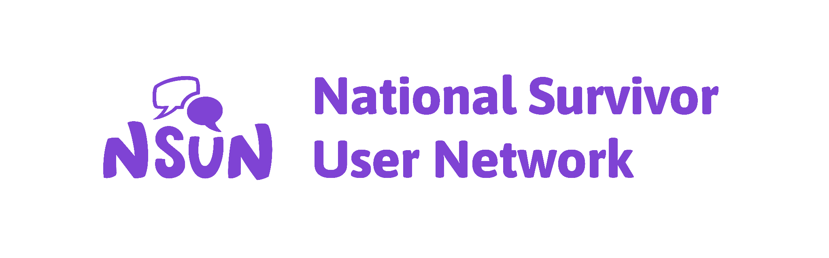

Modernising support for independent living: the health and disability Green Paper (April 2024)

Response from the National Survivor User Network

21st of July, 2024

- Introduction

  - The National Survivor User Network (NSUN) is a user-led charity and membership organisation of grassroots community mental health groups and people who have lived experience of mental ill-health, distress, or trauma. More information about our work and our membership can be found at: https://www.nsun.org.uk

  - Our work involves direct contact with thousands of people across the country who live with mental ill-health, distress, or trauma. A key strand of our work includes exploring the impact of the welfare system on the so-called mentally ill. We welcome the opportunity to respond to the Green Paper on the future of Personal Independence Payment (PIP).

  - Along with the Disability Benefits Consortium, we view the list of questions set out in the Green Paper consultation as predicated on the assumption that PIP should be restricted. This is not a premise we accept.

  - Instead, our response highlights key themes we are hearing from our membership in relation to mental ill-health and welfare reforms.

  - The issues we highlight are threefold:

    - Motivations for reform (Section 2)
    - Disability, mental health, and poverty (Section 3)
    - Impact of proposed reforms to PIP (Section 4)

- Motivations for reform

  - It is clear that the Green Paper is motivated by a wish to reduce the number of people claiming PIP and therefore the cost of the welfare bill.

  - We are concerned that these reforms are based on assumptions that people are wrongfully claiming PIP, and that Disabled people (including those with lived experience of mental ill-health, distress, and trauma) are a burden to the economy. PIP reforms must be read in line with proposed welfare reforms more broadly, in which the previous government has consistently framed Disabled people as injurious to the economy and therefore, society as a whole.

  - The idea that Disabled people are a “burden” is not only archaic but also stigmatising and dangerous. We hope that this government will work to challenge rather than further entrench stigma around Disabled lives.

  - PIP is not an out-of-work benefit. In many instances PIP enables people to work rather than dissuading them from doing so. Removing people’s eligibility for PIP will mean that some people may have to stop working. It is therefore inaccurate to position reforms to PIP as increasing employment among Disabled people.

  - While it may be appropriate to reconsider PIP a decade after its implementation, this must be rooted in the belief that Disabled people are deserving of support, people are valuable beyond their contributions to the labour market, and that the state has a responsibility to care for vulnerable people.

- Disability, mental health and poverty

  - Recent changes to welfare provision have made it increasingly difficult to access financial support. This includes the two child limit, bedroom tax, and increased sanctions. Many people are also frozen out of the benefits system through programmes such as the No Recourse to Public Funds condition.

  - Particular barriers are faced by those living with mental ill-health, distress, and trauma when trying to access welfare support (including PIP). In many instances, interactions with the Department of Work and Pensions have resulted in serious harm, mental health crises, and deaths by suicide (Rethink, 2021; Deaths by Welfare, 2024).

  - Recent research by the Joseph Rowntree Foundation shows that poverty in the UK is deepening, and states that Disabled people are twice as likely to live in poverty compared to working-age adults that are not disabled. This is in part due to the additional costs associated with disability, as well as additional barriers to work that this group faces.

  - It is well known that poverty is a key risk factor for mental ill-health (Ridley et al, 2020; Knifton and Inglis, 2020). It is also known that socioeconomic disadvantage significantly increases the risk of a person dying by suicide (Samaritans, 2023).

  - Experiences of poverty and mental ill-health create a spiralling effect - research shows that those living with mental ill-health are more likely to live in poverty, and that poverty often leads to mental ill-health (Mind, 2021).

  - At the same time, those living with so-called mental-ill health have been some of the hardest hit by recent global events and policy changes; including welfare reforms, increasing housing insecurity, the cost of living crisis, and COVID-19 (Rose et al, 2020).

  - It is clear that current mental health provision is unable to keep up with rising rates of distress in the general population. The most recent estimates suggest that at least 1.2 million people are on a waiting list for mental health services (National Audit Office, 2023), and research shows that many people’s mental health deteriorates while on a waiting list (Rethink, 2018).

  - A government concerned with improving wellbeing would also face issues in current mental health provision - recognising the increasingly document harms in current care provision and working to improve care beyond simply adding more staff to the NHS workforce. Reforms to welfare support (including PIP) should not be predicated on the assumption that NHS mental health care is a fit, capable, or sufficient alternative to financial support.

  - Only when the above issues are addressed will we see long-term improvements in mental health across the UK population.

- The impact of proposed reforms

  - Reforms set out in the Green Paper have been widely criticised by groups supporting Disabled people. Primarily, our concerns echo those raised by the Disability Benefits Consortium (DBC) in their response to this consultation. Rather than reiterating the detailed commentary on individual reforms offered by the DBC, we highlight some key issues we feel have been inadequately recognised in the reform process.

  - Firstly, proposed reforms fail to acknowledge the ways that the current welfare system disadvantages and causes distress to Disabled people, including those living with mental ill-health, distress, and trauma.

  - Secondly, the proposed reforms do not recognise the ongoing, continuous, and unexpected costs of living with a disability. For example, changing PIP to a one-off payment fails to account for the ongoing nature of disability. Equally, changing PIP to a catalogue or voucher based system undermines Disabled people’s autonomy by removing their ability to make their own choices, and fails to account for changes in people’s needs.
.
  - We are concerned about the chilling effects of proposed reforms. There are various eventualities that have been inadequately recognised in the proposed reforms and structure of the consultation questions. This includes:

    - For some, reforms to PIP will force more Disabled people into poverty, thereby exacerbating rather than reducing mental ill-health, distress, and trauma.

    - For others, reforms will force more Disabled people into unsafe working conditions.

    - Finally, many people who find themselves no longer eligible for PIP may be forced to stop working. This is because for many, receiving PIP enables people to work rather than dissuading them from doing so.

- Conclusion

  - We believe that the proposed reforms to PIP would serve to increase the financial insecurity and therefore distress of Disabled people. This is dangerous in any case, but especially so at a time when more people than ever are living with mental ill-health, which is often caused or exacerbated by experiences of financial hardship and poverty.

  - We urge the current government to focus on tackling the root causes of rising mental ill-health, distress, and trauma that mean people require support in the first place.

  - We believe that the state has a responsibility to ensure people are protected from poverty, including ensuring they have access to sufficient, fair, and ongoing support from the welfare system. We believe that PIP forms a vital part of this support.

  - We also believe that Disabled people, including those living with mental ill-health, are important and valuable members of our society. We believe that all people deserve to live nourishing, autonomous lives, free from poverty.

Further information is available from:

Kieran Lewis
Rights and Migration Policy Officer
National Survivor User Network

E-mail: kieran.lewis@nsun.org.uk
Please also copy to: courtney.buckler@nsun.org.uk

National Survivor User Network, 2024. NSUN responds: mental health and benefits reform. Available: https://www.nsun.org.uk/news/nsun-responds-mental-health-and-benefits-reform/
National Survivor User Network, 2024. Welfare support is mental health care. Available: https://www.nsun.org.uk/wp-content/uploads/2024/01/Welfare-support-is-mental-health-care-NSUN-briefing.pdf
Joseph Rowntree Foundation, 2024. UK Poverty 2024. Available: https://www.jrf.org.uk/uk-poverty-2024-the-essential-guide-to-understanding-poverty-in-the-uk
Samaritans, 2017. Socioeconomic disadvantage and suicidal behaviour. Available: https://media.samaritans.org/documents/Socioeconomic_disadvantage_and_suicidal_behaviour_-_Full.pdf
Rethink, 2018. Right treatment, right time. Available: https://www.rethink.org/media/dz4b1ydr/right-treatment-right-time-report.pdf
National Audit Office, Department of Health & Social Care, 2023. Progress in improving mental health services in England. Available: https://www.nao.org.uk/wp-content/uploads/2023/02/Progress-in-improving-mental-health-services-CS.pdf
Rethink, 2021. Tip of the Iceberg? Deaths and Serious Harm in the Benefits System. Available: https://www.rethink.org/media/4758/tip-of-the-iceberg.pdf
Mind, 2021. Fighting for the Mental Health of people living in poverty. Available: https://www.mind.org.uk/media/12428/final_poverty-scoping-research-report.pdf?_adal_ca=cg%3DOrganic.1720614053934&_adal_cw=1720533374694.1720614053934
Rose et al, 2020. The social underpinnings of mental distress in the time of COVID-19 - time for urgent action. Available: https://www.ncbi.nlm.nih.gov/pmc/articles/PMC7411522/
Ridley et al, 2020. Poverty, Depression, and Anxiety: Causal evidence and mechanisms. Available: https://www.nber.org/papers/w27157
National Survivor User Network, 2024. NSUN statement on the General Election: Our hopes. Available: https://www.nsun.org.uk/news/nsun-statement-on-the-general-election-our-hopes/
Deaths by Welfare, 2024. Available: https://deathsbywelfare.org/
Knifton and Inglis, 2020. Poverty and mental health: policy, practice and research implications. Available: https://www.ncbi.nlm.nih.gov/pmc/articles/PMC7525587/

