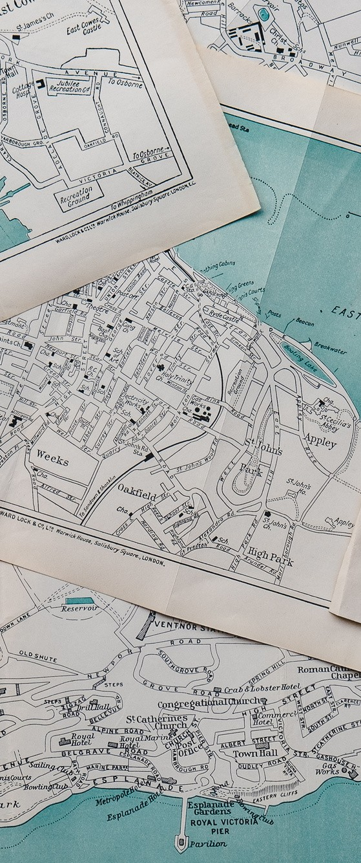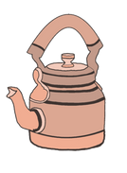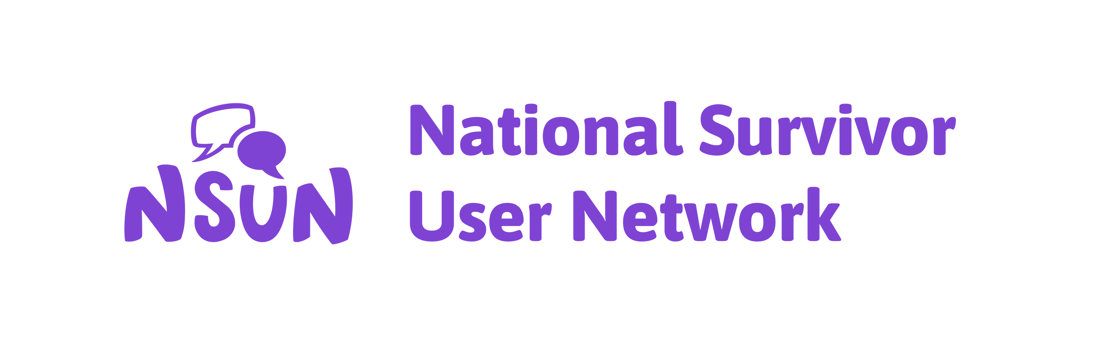

**Mapping Resilience and Sustainability**

Project Report

**The Teapot Collective**

**CONTENTS**

About Teapot **2**

About This Report **3**

Methodology **3**

Our Co-Creators **6**

Four Approaches **8**

My Thoughts on Resilience & Future Research

**14**

Reflections **16**

Call To Funders **16**

Acknowledgements **17**

Links **18**

**ABOUT TEAPOT**

I’m Amy, the author of this report and here’s a little about me:

I'd describe myself as passionate, curious and a lifelong learner. I'm neurodivergent, queer and mixed Indian & British. I'm a community activist. I founded along with my comrades an anti-racist organisation here in York, [York Anti Racist Collective](https://yarc.uk/), that focuses on healing from racial and intergenerational trauma through building community, engaging in creative practice and cultivating joy.

I founded The Teapot Collective along with my life partner, Jay Sullivan, who is our in-house animator too! We work with organisations, predominantly charities, to support them with embedding trauma-informed, decolonial and intersectional practices as well as introducing equity and inclusion more broadly.

Why Teapot? I personally love teapots and anything tea-related and also we'd like to create that feeling of sitting down sharing tea and chatting together when we facilitate workshops, groups and sessions. Tea is a drink that exists across cultures and brings people together. Jay came up with the name, it was such a joyous moment when Jay shared this idea with me.

The final part of The Teapot Collective is Teapot Yoga. I found that myself as well as my close friends and networks were burning out, people who are heavily involved in movement work across the spectrum e.g. disability justice, anti-racism and people with mental ill-health fighting stigma.

I began to learn the importance of having a spiritual practice in order to prevent burnout and centre self and collective care as part of my activism. The systems are designed in a way to burn us out and my act of resistance is to maintain my health whilst being in this work. My go-to phrase about our Teapot Yoga offering is: we help the dreamers and doers of liberation to maintain hope by being in community using the ancient magic of yoga.

**ABOUT THIS REPORT**

The purpose of this research is to understand how collaborations and partnerships between London-based user-led groups (ULGs) build resilience and sustainability.

This report shares four approaches to building resilience and sustainability which are drawn from conversations with London- based ULGs. Based on those conversations, we’ve also produced two online resources for ULGs: [an animated self-guided workshop](https://youtu.be/KcNmOcI06Yg) and an [online guide for mutual aid and food projects](https://www.nsun.org.uk/wp-content/uploads/2024/07/Mutual-aid-and-food-project-guide-NSUN-2024.pdf).

**METHODOLOGY**

At The Teapot Collective (Teapot) and National Survivor User Network (NSUN), we strive to engage in anti-oppressive research, which means designing a methodology that feels less extractive, more collaborative, while also recognising the power dynamics between researcher and the people participating in the research.

Payment for the organisations who contribute is an essential part of this and NSUN had already factored this into the project budget.

In addition, from the offset, we designed the research in a way that meant the ULGs are positioned as co-creators of the outcomes i.e. the four approaches as well as the two resources. For future research, we suggest that we involve the organisations in designing the research process including the methodology, with payment.

This will offer further learnings for ULGs as well as partners reading the research.

We strived for the research to not only support the research questions but also be helpful for the ULGs that participated. I use my experience as a member of a small ULG to assist me in thinking about the content that might be helpful, which also addresses what we set out to understand. We decided to offer organisations a two- hour visioning workshop or a one-hour interview either in person or online.

The workshop encourages groups to take the time to dream up their vision, a piece of work that tends to be hard to complete due to limited capacity. The one-hour interview focused specifically on collaborations and partnerships as a tool for building resilience.

The structure of the workshop was as follows:

Identifying the roots of the project

Recognising the gifts of the project (from Adrienne Marie Brown’s book, *Emergent Strategy*)

Dreaming up the vision for the project. Dream about the year 2050, in an ideal world, what will your organisation be doing? What about the communities you work with?

Complete the newspaper activity. What are the newspaper headlines that your organisation would need to see to know that you’re moving toward your vision?

Identify the partnerships and collaborations that would help you move toward this vision.

Think about the next 12 months, what would you like to focus on that would mean you’re working toward your vision?

We collated a list of approximately 40 ULGs across London, ensuring that we had diverse identities and services represented. We emailed everyone from the list inviting them to participate in this piece of research. After some email conversations, six organisations confirmed. We completed four online workshops, one in person workshop and one interview.

The ULGs, the co-creators of this research, are listed on the following page. For each of the organisations we’ve shared some details about their work taken from their websites.

**ALHASANIYA MOROCCAN WOMEN’S CENTRE**

AlHasaniya Moroccan Women’s Centre seeks to serve the health, welfare, educational and cultural needs of Moroccan and Arabic- speaking women and their families residing in the Royal Borough of Kensington & Chelsea and London-wide.

**ASIAN PEOPLE’S DISABILITY ALLIANCE (APDA)**

APDA campaigns on ensuring voices of Asian Disabled people, carers and their families are heard and their needs and rights are respected, understood and the inequalities are addressed.

APDA provides services appropriate to the needs of disabled Asian people and their carers, and those who are elderly and isolated.

We’ve been providing our culturally sensitive support to the local Asian communities from our London centre for over 30 years.

**LONDON LGBTQ COMMUNITY CENTRE**

The London LGBTQ+ Community Centre is a sober, intersectional community centre and café where all LGBTQ+ people are welcome, supported, can build connections and can flourish. Our vision is for a more connected, belonging and thriving LGBTQ+ community in London.

**NATIONAL UGLY MUGS**

National Ugly Mugs (NUM) is a pioneering national organisation that provides greater access to justice and protection for sex workers who are often targeted by dangerous individuals and face obstacles to reporting, access to service and police protection.

Those who harm sex workers offend against all of us!

**SPRING COMMUNITY HUB**

The mission of Spring Community Hub is that through a ‘Community Hub’ and full activity programme, local people in or at risk of crisis will be supported along their journey to move on and achieve full social, economic and emotional independence to live healthy lives in a community which supports each other.

**USEMI**

USEMI is a Swahili word that means SPEAKING and reads as YOU SEE ME.

With questions of voice and visibility as its central concerns, USEMI strives to offer culturally sensitive and anti-racist support to ethnically diverse communities. While one in 100 is likely to experience psychosis in the course of a lifetime, this incidence is four times higher in communities of colour.

The same applies to involuntary hospitalisation with Black and ethnically diverse individuals being disproportionately detained under the Mental Health Act.

USEMI advocates understanding and sensitivity to difference and diversity in its therapeutic work and a keen awareness of individuals’ background, culture and lifestyle.

**FOUR APPROACHES FOR BUILDING RESILIENCE AS A USER-LED GROUP**

These approaches emerged from discussions with the six ULGs about what it means to be a resilient & sustainable organisation.

**APPROACH 1: CONSISTENTLY CENTRE THE NEEDS OF THE COMMUNITIES YOU SERVE**

With this approach, the key to resilience is to be led by the needs of your community. This may mean that the ideas for the project may completely change. The group may have set out to do a food project, however once the group has discovered the changing needs of the community, the project develops into a service for people to learn a new language, for example.

The longstanding ULGs we spoke to shared that they had to become comfortable with stopping some of their beloved projects and ideas in order to move with the changing needs of the community. They centre the needs of the community they serve and accept the changes that come with this.

Therefore, maintaining open dialogue with the communities you work with and creating the space for people to give candid and honest feedback is fundamental in building a resilient and sustainable organisation.

**APPROACH 2: SEEK OUT PARTNERS AND COLLABORATORS (YOUR CO-CONSPIRATORS) WHO HOLD SIMILAR VALUES TO YOUR OWN.**

Co-conspirators take action beyond allyship. Here’s a definition that’s specifically referring to anti-racist activism and can be applied across social justice movement work:

“A co-conspirator is someone who is compelled to take action against racism and oppression regardless of the consequences. A co-conspirator is unapologetically anti-racist and committed to dismantling the system of White supremacy culture and the benefits they receive from it.” (National Education Association)

If we attempt to decolonise the way we understand partnerships and collaborations, we may find beauty in building connections.

We release ourselves from the capitalist need to only build collaborations to receive something tangible in return. These sorts of relationships occur between funders and grantees, for example. This dynamic doesn’t have to be the only way that we build partnerships.

Co-conspirators may make groups feel less alone in their radical approach to community building and activism. ULGs may never tangibly work with co-conspirators, there may be no Key Performance Indicators (KPIs) or report writing. Simply knowing their existence and being connected to them is enough, even if this is solely an online connection. Technically there is an exchange here, a transaction, but it’s less entwined with capitalism and more centred in community care and solidarity.

In addition, a co-conspirator may not be in the places that ULGs would assume. They may be ULGs that are working with a different community, based in a different geographical location or providing a vastly different service. Although they are different, co- conspirators will often both share the same core values and their vision and approach to the work aligns.

In order to identify a co-conspirator, particularly if the groups are looking to work on a project together, completing a review could be helpful. This review could involve assessing risk and gathering a deep understanding of a potential partner organisation before committing to any collaborative work.

Unfortunately some ULGs feel like partnerships and collaborations can cause harm due to their performative nature and this comes from experience.

Therefore, in these instances, taking the time to complete a review of a potential partner could prevent some harm.

Oftentimes user-led groups feel they have to maintain a partnership due to the unequal power dynamic and that there is a greater risk of harm if the relationship ends. For instances like these, it is challenging to prevent harm from occurring, so it’s about harm reduction. How can we maintain this relationship whilst also keeping our group as safe and supported as we can? Are there any other groups, maybe co-conspirators, who have had similar experiences who could support us?

In addition, we’d like to note here that as ULGs, it’s near to impossible to be certain whether or not a partnership or collaboration is going to cause harm, mainly due to the subtle nature of how discrimination, such as racism, can operate or how other problematic behaviours surface. Therefore, we encourage ULGs to do what they can and be gentle with each other should the partnership turn out to be harmful.

Here’s some of the things a ULG may wish to explore for a review:

Does this organisation hold similar values to your own?

What’s their approach to their work? Does this approach align with yours?

Initially discuss with your group if there may be any underlying or unsaid intentions for this organisation wanting to work with you e.g. as a group that has access to global majority people, does this organisation need that access? You may decide that this is okay. If you aren’t sure about this and feel able, you may choose to have a radically honest conversation with the potential partner to explore this.

Upon agreeing to collaborate with a partner you may choose to create a contract-like document, not the legal type, but one that covers things like: how we will work together, our boundaries e.g. things we won’t accept or engage in, how to give and receive feedback and a clear and accessible path to exit the collaboration should you wish to.

**APPROACH 3: VISIONING, RECOGNISING YOUR GIFTS AND PLANNING FOR THE FUTURE CAN BE USED AS A TOOL TO BUILD RESILIENCE**

In our collective up in York, we do not have much time and capacity, yet what we’re beginning to understand is that taking the time to vision what we’d like to see change in York is an essential tool for building our resilience. If we are able to have a vision for our community in mind it means that when we come up against challenges we are able to stay rooted in our vision and overcome the challenges from these sturdier foundations.

With the support of the wonderful 6 London-based organisations listed at the beginning of this report we co-developed a self- guided workshop for ULGs to explore their vision as a tool for building resilience. Jay Sullivan from Dandelion Animation and The Teapot Collective transformed our content into an animation. If you’d like, [follow this link to watch](https://youtu.be/KcNmOcI06Yg).

Moreover, Adrienne Marie Brown shares in her book, *Emergent Strategy*, that it’s important to recognise and celebrate the gifts of the ULG. The gifts are the things that will support ULGs in moving toward their collective vision.

**APPROACH 4: MAPPING AS AN EXERCISE CAN ASSIST YOU IN UNDERSTANDING YOUR COMMUNITY IN DEPTH**

This approach suggests that ULGs create a community resource map to build resilience. A community resource map may support groups to connect with their geographical area, the community around them and identify potential collaboration opportunities or discovering co-conspirators.

We collaborated with Felicia Borshin, the CEO & Founder of Spring Community Hub, to develop a 3 Step Guide for groups or individuals who are looking to start a new community project, particularly for food and mutual aid projects. Step 1 of the guide is titled Capture, and provides instructions on how you could go about creating a community resource map.

A community resource map can be used as a tool to identify and be led by the needs of the community, as well as gathering an understanding of what already exists in the local area so that capacity is created for collaboration. This supports Approach 1, in that, by getting to know the local community, the group may be better able to be led by the needs of the community.

If you’d like to read the 3 Step Guide, follow this link:

[3 Step Guide for Food & Mutual Aid Projects Link](https://www.nsun.org.uk/wp-content/uploads/2024/07/Mutual-aid-and-food-project-guide-NSUN-2024.pdf)

**MY THOUGHTS ON RESILIENCE & FUTURE RESEARCH**

I have a mixed relationship to the word resilience.

Resilience is a term that is regularly used to describe Black and Global Majority people, as well as other groups that are systemically oppressed. We are resilient, there’s no question about that, but describing ourselves as resilient and working to build our organisational resilience, I believe, can distract us from the fact that we need abolition. The end of empires and colonisation, the end of capitalism, the end of police, prisons, all the things.

“I dream of never being called resilient again. I’m exhausted by strength. I want support. I want softness. I want ease. I want to be amongst kin. Not patted on the back for how well I take a hit.” Words by Zandashé L’orealia Brown

These words are beautiful and the final sentence weighs on my heart. This is how I often view resilience.

In addition, the very idea of resilience could be seen as ableist:

“Ableism looks like calling people ‘inspiring’ for navigating a system designed for exclusion, while doing nothing to hold the system accountable” Shared by Gender Inclusive Schools.

Someone in the comments said “Or resilient.”

We’re rewarded for our efforts, we get our pat on the back, in becoming resilient people within our communities, often validated by the faces of systemic power, without the systems looking within and taking action to end systemic oppression.

We continue to see MBEs and OBEs, which are very clear examples of how the system, in this instance the monarchy, are so quick to reward people in our communities doing the “inspiring” work, but are not prepared to recognise their very active role in past and current colonial violence and responsibility for systemic oppression. In my eyes this is such a painful contradiction, it has my stomach in knots.

This research has co-designed approaches for ULGs to build resilience themselves, focusing on what they are already doing and could do more of. I’d like to see more research completed to further understand how systems of power, and those who hold resources, for example funders, are working toward reducing the need for resilience and undoing this harmful dynamic.

**REFLECTIONS**

Overall, this research indicates that partnerships and collaborations are an important, if not essential factor in building a resilient and sustainable organisation. Yet it is too simplistic to encourage groups to just go out and collaborate, due to the very real risks of harm for the organisation and the people within it, particularly user-led groups who experience intersectional discrimination, stigma and oppression.

Therefore this research encourages groups to approach collaborations and partnerships with nuance, considering creative and alternative ways of working together that actively resist the oppressive and extractive structures in which we find ourselves in.

**CALL TO FUNDERS**

This research outlines that it takes time, person-power, and hard work to build partnerships and collaborations, which in turn builds their organisational resilience and sustainability.

In order for ULGs to apply the learnings as outlined in this research, as well as other practices ULGs already use to build partnerships and collaboration, they must be financially resourced. This will reduce the risk of harm from performative action and enable groups to form collaborations that prioritise the wellbeing of the ULGs, rather than having to prioritise the financially viable collaborations due to a lack of resources.

My personal call to funders, with the power and resource that they hold, is to ask themselves:

What are we doing to dismantle systems of oppression so that we see a liberated world?

What are we doing so that the people we are hoping to resource never have the need to be resilient again?

I invite you to do the self-guided workshop and I suggest that one of your visions is: the people we resource no longer need to be resilient. Follow this dream, this vision, and see how you can take small steps today to be able to bring this into reality. I have the hope that we will all be liberated from resilience and it requires action from all levels, particularly those with access to power.

**ACKNOWLEDGEMENTS**

Jay Sullivan Ruairi White Zeenat Jeewa Kweku Benefo Ayesha Khapedi Hasina Ahmed

Fareeda Issace

Yasmin Rahman Monica Dobrican Dione Dalley Earl Pennycooke Felicia Boshorin

Daniel Gould Loftus

The Racial Justice Project team at NUM

**LINKS**

[National Education Association’s Definition of a Co-Conspirator](https://www.nea.org/racialjusticejourney#%3A~%3Atext%3DCo%2DConspirator%20Defined%26text%3DA%20co%2Dconspirator%20is%20someone%2Cbenefits%20they%20receive%20from%20it)

[Teapot’s Website](https://theteapotcollective.co.uk/)

[NSUN’s Website](https://www.nsun.org.uk/)

[Alhasaniya Moroccan Women’s Centre’s Website](https://www.al-hasaniya.org.uk/)

[Asian People’s Disability Alliance’s Website](https://apda.org.uk/)

[London LGBTQ Community Centre’s Website](https://londonlgbtqcentre.org/)

[National Ugly Mug’s Website](https://nationaluglymugs.org/)

[Spring Community Hub’s Website](https://www.cschub.co.uk/)

[More information about Usemi](https://ptp-usemi.org.uk/usemi.html)

[Visioning Self-Guided Workshop Animation](https://youtu.be/KcNmOcI06Yg)

[Food & Mutual Aid Project Guide](https://www.nsun.org.uk/wp-content/uploads/2024/07/Mutual-aid-and-food-project-guide-NSUN-2024.pdf)